**Week-2 JUnit Basic Testing Exercises**

1. **Setting Up JUnit**

**Scenario:**

You need to set up JUnit in your Java project to start writing unit tests.

**Code:**

**Calculator.java:**

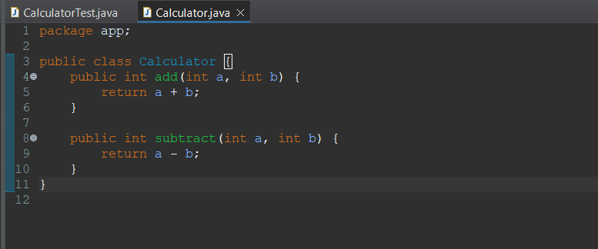

**CalculatorTest.java:**

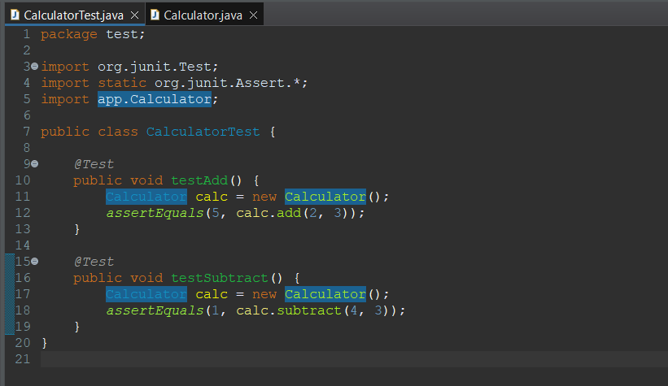

**Output:**

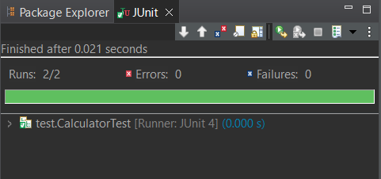

1. **Assertions in JUnit**

**Scenario:**

You need to use different assertions in JUnit to validate your test results.

**Code:**

**AssertionsTest.java**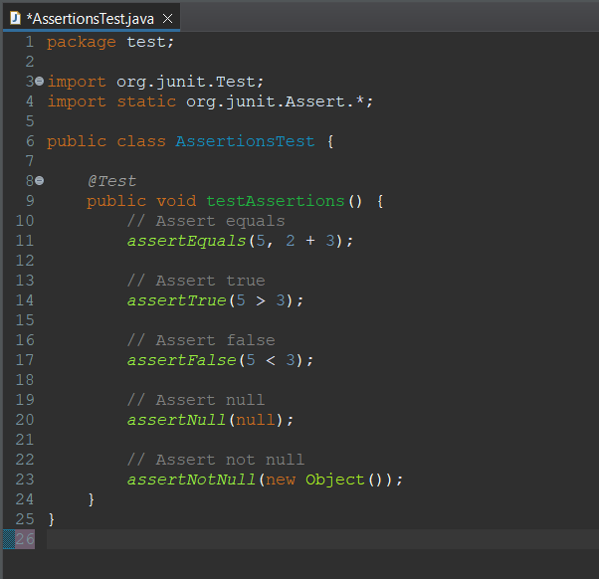

**Output:**

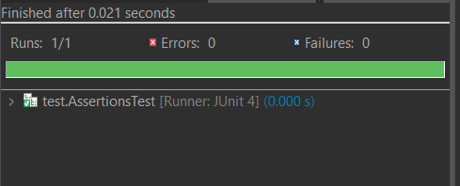

1. **Arrange-Act-Assert (AAA) Pattern, Test Fixtures, Setup and Teardown Methods in JUnit**

**Scenario:**

You need to organize your tests using the Arrange-Act-Assert (AAA) pattern and use setup and teardown methods.

**Code:**

**CalculatorTest.java:**

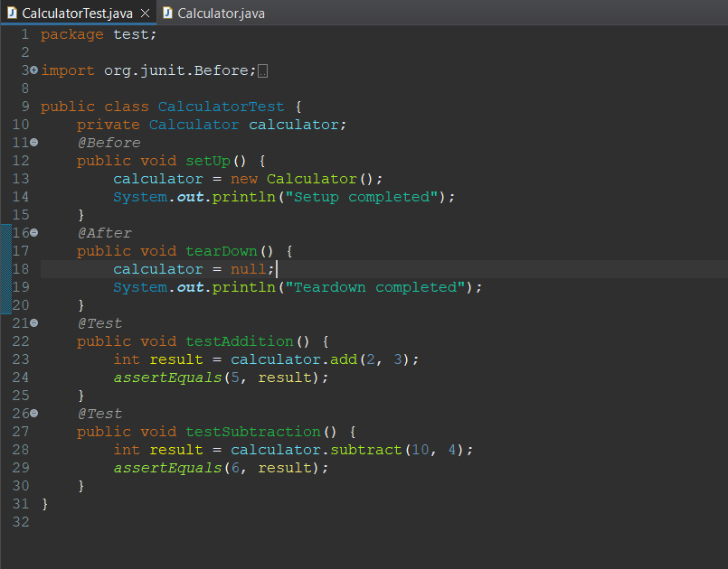

**Calculator.java**

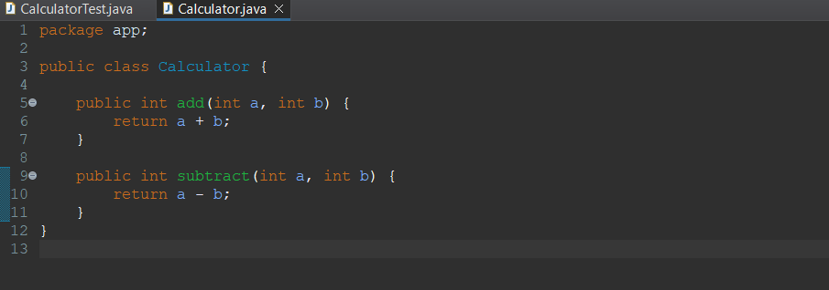

**Output:**

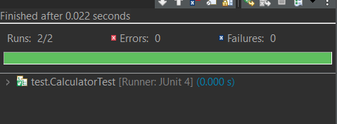

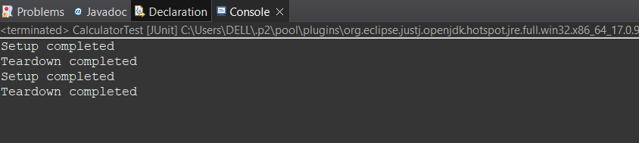

**Week-2 Mockito Exercises**

1. **Mocking and Stubbing**

**Scenario:** You need to test a service that depends on an external API. Use Mockito to mock the external API and stub its methods.

**Code:**

**ExternalAPI.java**

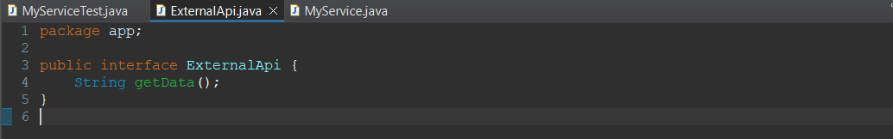

**MyService.java**

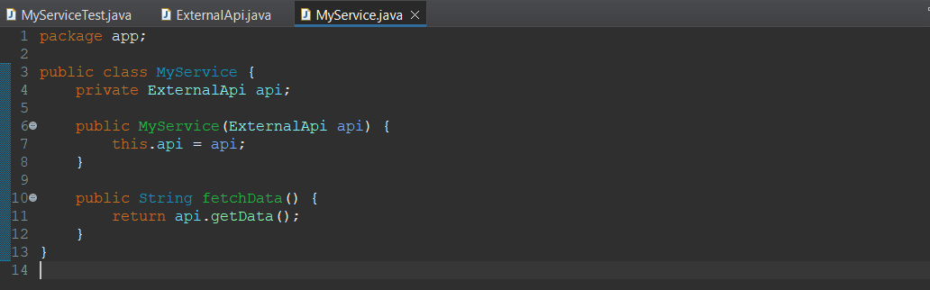

**MyServiceTest.java**

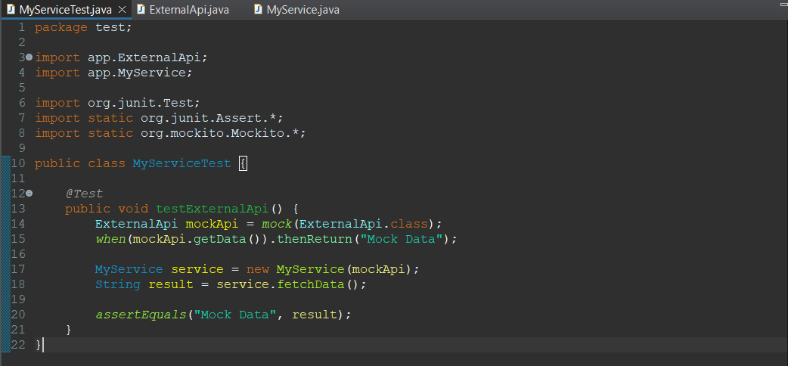

**Output:**

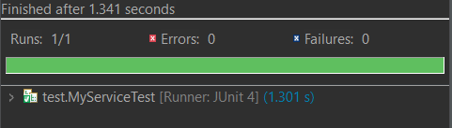

1. **Verifying Interactions**

**Scenario:** You need to ensure that a method is called with specific arguments.

**Code:**

**MyServiceTest.java**



**ExternalAPI.java**



**MyService.java**



**Output:**



**Week-2 SL4J Logging Exercises**

1. **Logging Error Messages and Warning Levels**

**Task:**

Write a Java application that demonstrates logging error messages and warning levels using SLF4J.

**Code:**

**LoggingExample.java**

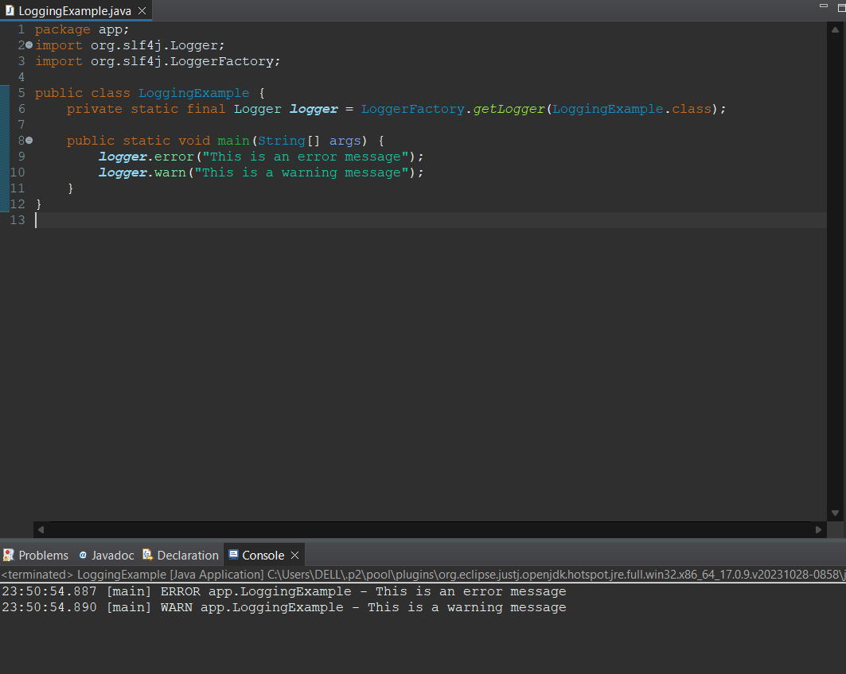

**Output:**

